Bubble Sort Algorithm:
def bubble_sort(numbers):
for i in range(len(numbers)):
for j in range(len(numbers) - i - 1):
if numbers[j] > numbers[j + 1]:
numbers[j], numbers[j + 1] = numbers[j + 1], numbers[j]
return numbers

numbers = [1, 3, 4, 7, 9]
print (bubble_sort(numbers))

Quick Sort Algorithm Code:
def quick_sort(numbers):
if len(numbers) <= 1:
return numbers
else:
pivot = numbers.pop()

numbers_greater = []
numbers_lower = []

for number in numbers:
if number > pivot:
numbers_greater.append(number)
else:
numbers_lower.append(number)

return quick_sort(numbers_lower) + [pivot] + quick_sort(numbers_greater)

numbers = [1, 3, 4, 7, 9, 2, 6, 7, 14]
print (quick_sort(numbers))

Comparative Empirical Time Complexity Code:
import time
import random
import matplotlib.pyplot as plt

# Define different list sizes to test
sizes = [100, 200, 300, 400, 500, 600, 700, 800, 900, 1000]
quick_times = []
bubble_times = []

# Measure execution time for each size
for size in sizes:
test_list = [random.randint(1, 1000) for _ in range(size)]
start = time.time()
quick_sort(test_list)
end = time.time()
quick_times.append(end - start)

# Measure execution time for each size
for size in sizes:
test_list = [random.randint(1, 1000) for _ in range(size)]
start = time.time()
bubble_sort(test_list)
end = time.time()
bubble_times.append(end - start)

# Plot the sizes against the measured execution times
plt.figure(figsize=(8, 5))
plt.plot(sizes, quick_times, marker='o', color = 'r', linestyle='-')
plt.plot(sizes, bubble_times, marker='o', color = 'b', linestyle='-')
plt.title('Quick Sort VS Bubble Sort Execution Time')
plt.xlabel('Input Size (n)')
plt.ylabel('Time Taken (seconds)')
plt.grid(True)
plt.show()

Quick Sort VS Bubble Sort Time Complexity Graph:
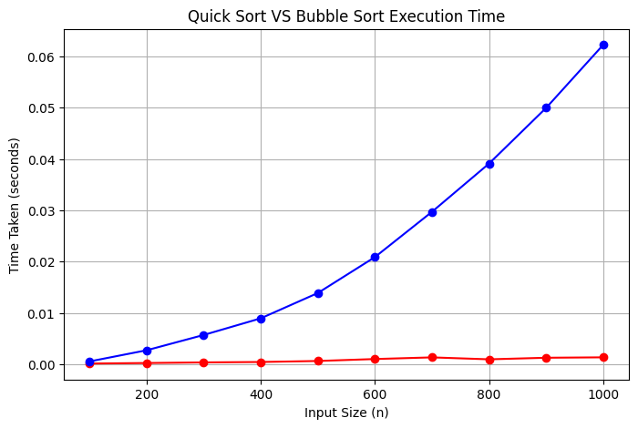

Functionality of the codes:
Bubble sort essentially “bubbles” the larger numbers towards the end of a list until all numbers are sorted. The Bubble Sort algorithm I have created uses a nested loop. The initial ‘for’ loop (outer loop) means that the iterations of the inner loop will repeat until all numbers are sorted, whilst the inner loop compares adjacent numbers repeatedly and swaps them if the condition numbers[j] > numbers[j + 1] is true.
The Quick Sort algorithm uses recursion, meaning the function repeatedly calls itself to sort the smaller lists, “numbers_lower” and “numbers_greater” than the pivot. Each time it is called, a new pivot is selected and the remaining numbers are divided into two groups. This continues until the lists contain one or fewer numbers (if len(numbers) <= 1), at which point they are returned and combined to produce the final sorted list. The pivot is selected using the “.pop” function which removes it from the list and stores it as a variable until it is added back during the return statement.

Bubble Sort and Quick Sort Efficiency – Small vs. Large Datasets:
The bubble sort algorithm has a time complexity of O(n²) in best and worst cases because the outer loop will complete as many iterations as numbers there are, there is no early-exit condition. This means that as datasets get larger, it will be less efficient than quick sort which has O(n log n) average time complexity and O(n²) in worst cases. Although the quick sort algorithm has a larger space complexity because it uses recursion, the better time complexity still makes it more efficient than bubble sort for large datasets.
Comparing Bubble Sort and Quick Sort and their Real-World Use Cases:
Bubble sort uses an iterative approach to sorting the lists, which is beneficial in terms of space complexity, however, it has a much larger time complexity which renders it inefficient for large datasets. It can be used for teaching or introducing sorting method, or where datasets are very small. Quick sort, comparatively, performs much better with larger datasets with its divide and conquer method, and is most widely used in the real world, e.g., large data analysis (Rai, Parmar and Sharma, 2025)

References:
Rai, M., Parmar, H., Sharma, S. (2025) ‘Comparative Analysis of Sorting Algorithms: Time Complexity and Practical Applications’, 2025 3rd International Conference on Intelligent Data Communication Technologies and Internet of Things (IDCIoT), Bengaluru, India, 05-07 February. IEEE. Pp. 26-32. Available at: 10.1109/IDCIOT64235.2025.10915063.

